Program Code:

#!/bin/bash
pwd
date

Sample Output:

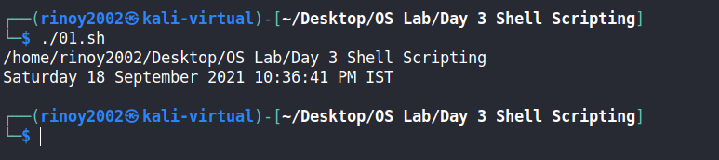

Program Code:

#!/bin/bash
a=20
b=10
sum=$(($a + $b))
diff=$(($a - $b))
product=$(($a * $b))
division=$(($a / $b))
echo " Sum : $sum"
echo " Difference : $diff"
echo " Product : $product"
echo " Division : $division"

Sample Output:

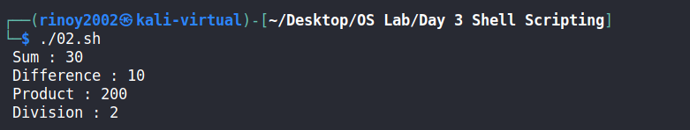

Program Code:

#!/bin/bash
echo "Count of Arguments: $#"
echo $*

Sample Output:

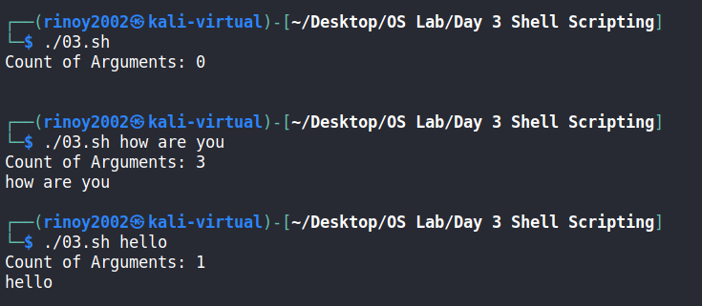

Program Code:

#!/bin/bash
if [ $# == 3 ]
then
echo "No. of Arguments is 3"
else
echo "No. of Arguments is not 3"
fi

Sample Output:

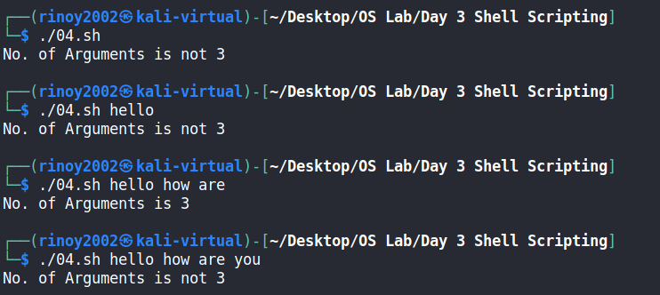

Program Code:

#! /bin/bash
if [ $# -lt 2 ]
then
echo 'pass 2 Strings'
elif [ $1 == $2 ]
then
echo "both strings are same"
elif [ $1 != $2 ]
then
"both strings are different"
fi

Sample Output:

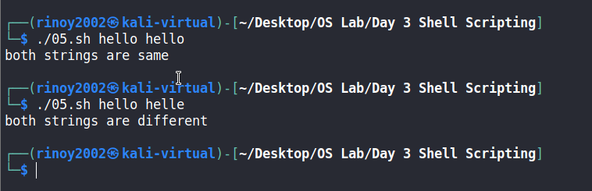
Program Code:

#!/bin/bash
FILE=$1
if [ -e "$FILE" ]
then
echo "file found"
else
echo "file not found"
fi

Sample Output:

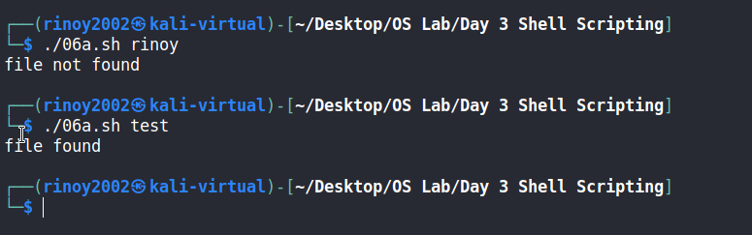
Program Code:

#!/bin/bash
FILE=$1
if [ -e "$FILE" ]
then
echo "file found"
mv $1 $2
echo "file renamed"
else
echo "file not found"
fi
echo "No. of Arguments is $#"

Sample Output:

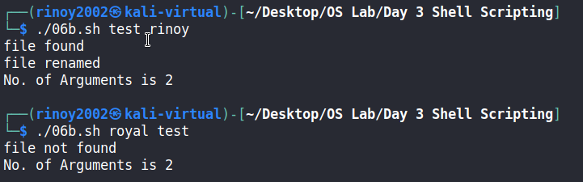

Program Code:

#!/bin/bash
echo "enter the file name :"
read file
if [ -e "$file" ]
then
echo "enter the word :"
read word
isfound=$(grep -cw $word $file)
if [ $isfound -gt 0 ]
then
echo "word found"
else
echo "word not found"
fi
else
echo "file not found"
fi

Sample Output:

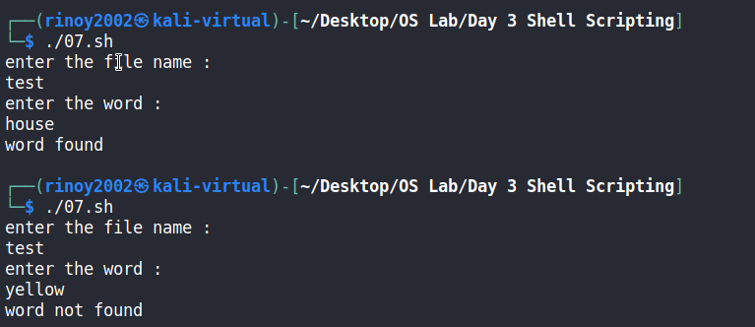
Program Code:

#!/bin/bash
if [ -e "file1" ]
then
if [ -e "file2" ]
then
cat file1>>file2
echo "file2 exists,file1 appended to file2"
else
cp file1 file2
echo "file2 doesn't exists,file1 copied to file2"
fi
fi

Sample Output:

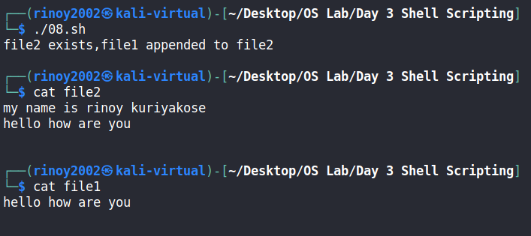

Program Code:

#!/bin/bash
if [ -e "firstfile" ] && [ -e "secondfile" ]
then
head firstfile>>$1
head secondfile>>$1
cat $1
else
echo "file not found"
fi

Sample Output:

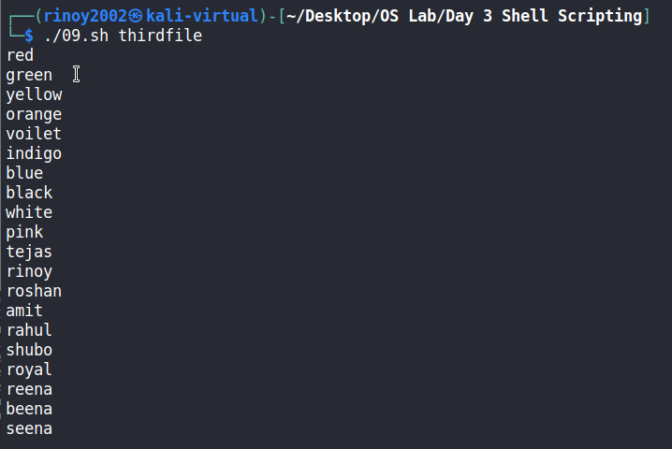

Program Code:

#!/bin/bash
echo "matches found are :"
find -name "${1}*" -type f | wc -l

Sample Output:

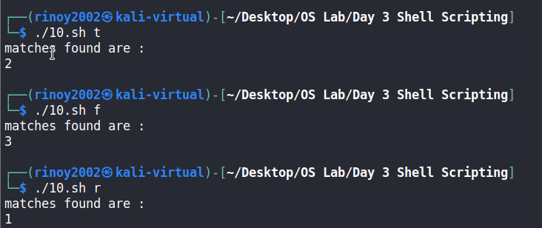

Program Code:

#!/bin/bash
head -n1 test | tr 'aeiou' 'AEIOU' > output
cat output

Sample Output:

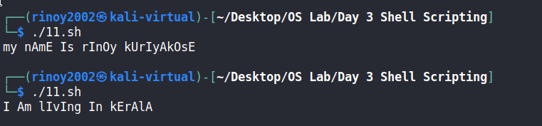

Program Code:

#!/bin/bash
echo "enter the name :"
read name
echo "reverse : "
echo $name | rev
echo "length : "
echo ${#name}

Sample Output:

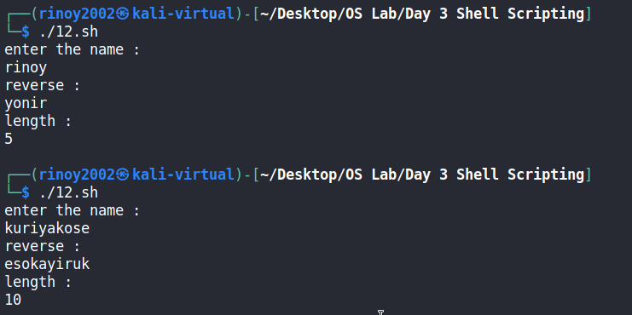

Program Code:

#!/bin/bash
if [ -e "school.dat"]
then
cat school.dat | sort -r -k3
else
echo "file not found"
fi

Sample Output:

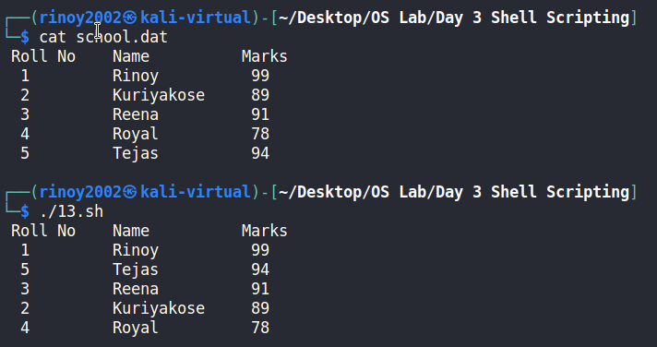

Program Code:

#!/bin/bash
echo "enter value n :"
read n
for ((i=1;i<=n;i++))
do
sum=$((sum + i))
done
echo "sum : $sum"

Sample Output:

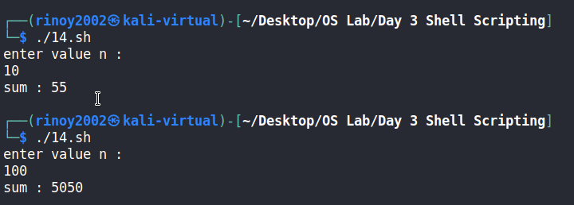

Program Code:

#!/bin/bash
echo " MENU "
echo "1.Sunday"
echo "2.Monday"
echo "3.Tuesday"
echo "4.Wednesday"
echo "5.Thursday"
echo "6.Friday"
echo "7.Saturday"
echo "enter the choice : "
read option
case $option in
1)
echo "Sunday"
;;
2)
echo "Monday"
;;
3)
echo "Tuesday"
;;
4)
echo "Wednesday"
;;
5)
echo "Thursday"
;;
6)
echo "Friday"
;;
7)
echo "Saturday"
;;
*)
echo "Invalid Input"
;;
esac

Sample Output:

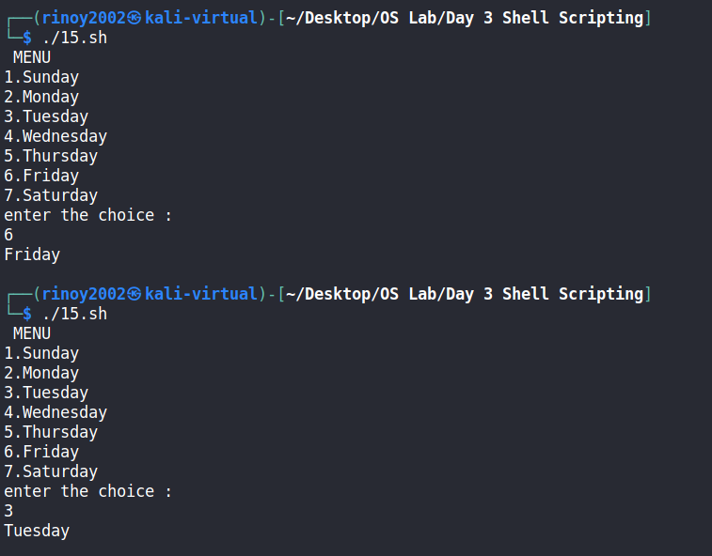

Program Code:

#!/bin/bash
echo -e " \nOperations:"
echo " 1)Addition: +"
echo " 2)Subtraction: -"
echo " 3)Multiplication: \*"
echo " 4)Division: /"
echo " 5)Modulus: %"
echo " 6)Exponent: ^"
echo " 7)Functions: sin() cos() tan() log() etc"
echo " 8)Parentheses: ()"
echo -ne " \nEnter the expression: "
read a
echo -e " \nResult: `awk "BEGIN{print $a}"`\n"

Sample Output:

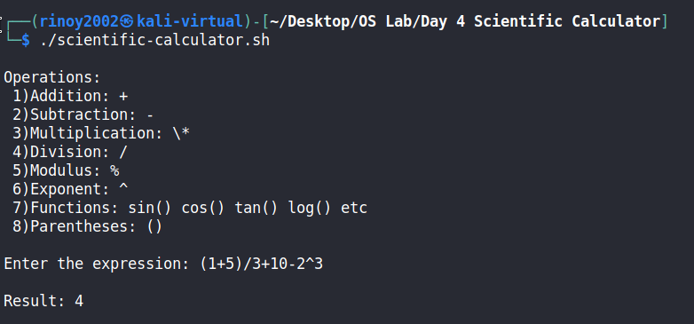
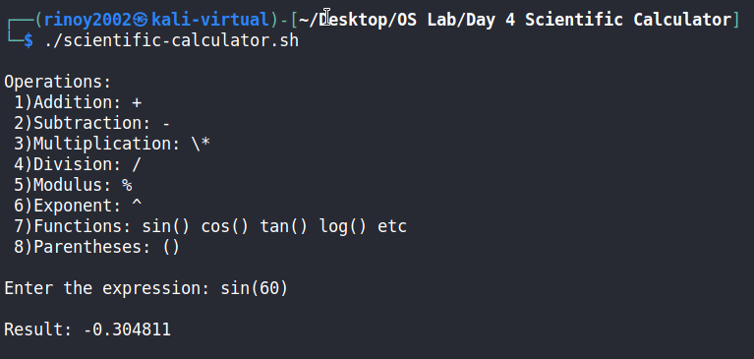
Program Code:

#include<stdio.h>
void main()
{
struct process{
int no;
float bt;
float at;
float tat;
float wt;
};
int n,i,j;
float time=0,temp1,temp2,temp3,avgtat,avgwt,stat=0,swt=0;
printf("no. of processes :");
scanf("%d",&n);
struct process p[n];
printf("burst time for the processes :\n");
for(i=0;i<n;i++){
printf("p[%d] : ",i+1);
scanf("%f",&p[i].bt);
}
printf("arrival time for the processes :\n");
for(i=0;i<n;i++){
printf("p[%d] : ",i+1);
scanf("%f",&p[i].at);
}
for(i=0;i<n;i++){
p[i].no = i+1;
}
for(i=0;i<n;i++){
for(j=0;j<n-i-1;j++){
if(p[j].at>p[j+1].at){
temp1 = p[j].no;
temp2 = p[j].bt;
temp3 = p[j].at;
p[j].no = p[j+1].no;
p[j].bt = p[j+1].bt;
p[j].at = p[j+1].at;
p[j+1].no = temp1;
p[j+1].bt = temp2;
p[j+1].at = temp3;
}
}
}
for(i=0;i<n;i++){
if(time<=p[i].at){
time =p[i].at;
}
time = time + p[i].bt;
p[i].tat = time-p[i].at;
stat = stat + p[i].tat;
p[i].wt = p[i].tat - p[i].bt;
swt = swt + p[i].wt;
}
avgtat = stat/n;
avgwt = swt/n;
printf("\n process | burst time | arrival time | turn-around time | waiting time \n");
printf(" ------------------------------------------------------------------------------\n");
for(i=0;i<n;i++){
printf(" p[%d] : ",p[i].no);
printf(" %.3f ns",p[i].bt);
printf(" %.3f ns",p[i].at);
printf(" %.3f ns",p[i].tat);
printf(" %.3f ns\n\n",p[i].wt);
}
printf(" average turn-around time : %.3f ns\n",avgtat);
printf(" average waiting time : %.3f ns\n",avgwt);
}

Sample Output:

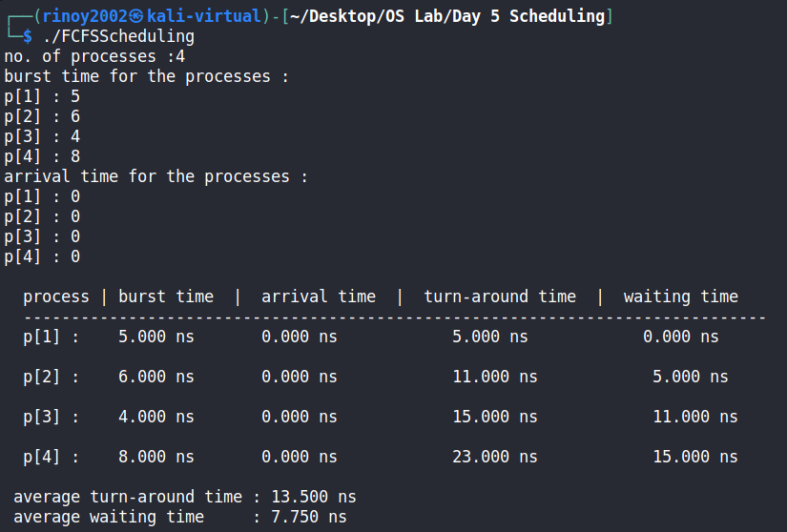

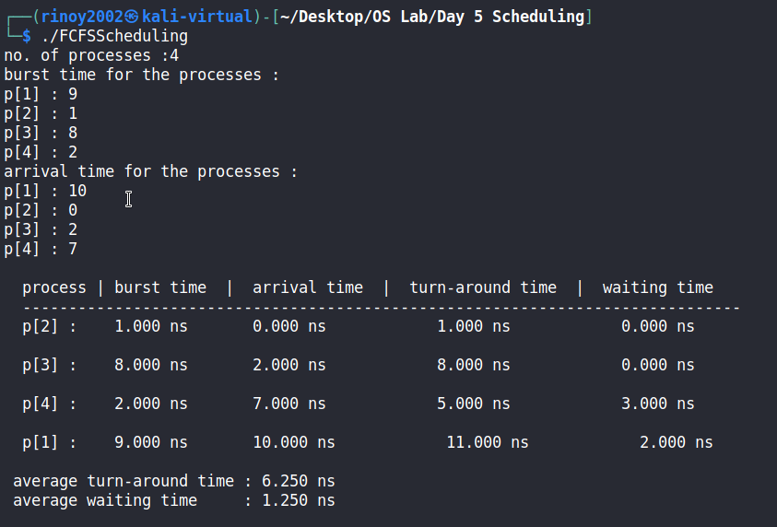
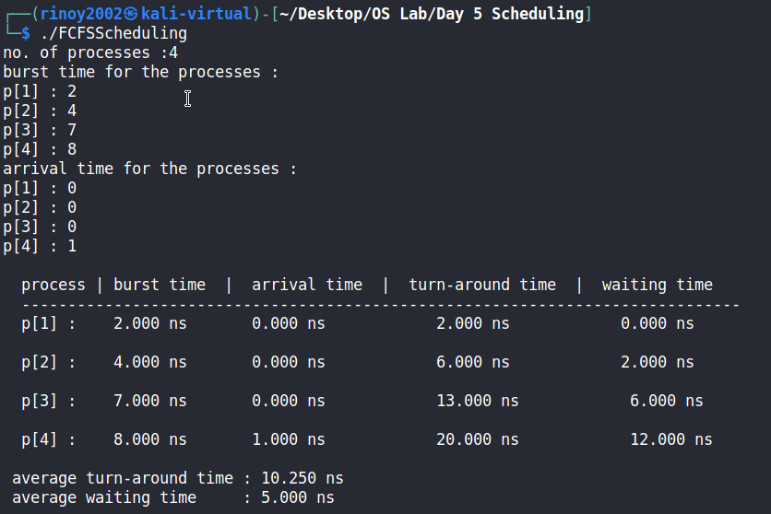

Program Code:

include<stdio.h>
void main()
{
struct process{
int no;
float bt;
float at;
float tat;
float wt;
};
int n,i,j,d,k=1;
float time=0,temp1,temp2,temp3,avgtat,avgwt,stat=0,swt=0,min,sum,btime;
printf("no. of processes :");
scanf("%d",&n);
struct process p[n];
printf("burst time for the processes :\n");
for(i=0;i<n;i++){
printf("p[%d] : ",i+1);
scanf("%f",&p[i].bt);
}
printf("arrival time for the processes :\n");
for(i=0;i<n;i++){
printf("p[%d] : ",i+1);
scanf("%f",&p[i].at);
}
for(i=0;i<n;i++){
p[i].no = i+1;
}
for(i=0;i<n;i++){
for(j=0;j<n-i-1;j++){
if(p[j].bt>p[j+1].bt){
temp1 = p[j].no;
temp2 = p[j].bt;
temp3 = p[j].at;
p[j].no = p[j+1].no;
p[j].bt = p[j+1].bt;
p[j].at = p[j+1].at;
p[j+1].no = temp1;
p[j+1].bt = temp2;
p[j+1].at = temp3;
}
}
}
for(i=0;i<n;i++){
for(j=0;j<n-i-1;j++){
if(p[j].at>p[j+1].at){
temp1 = p[j].no;
temp2 = p[j].bt;
temp3 = p[j].at;
p[j].no = p[j+1].no;
p[j].bt = p[j+1].bt;
p[j].at = p[j+1].at;
p[j+1].no = temp1;
p[j+1].bt = temp2;
p[j+1].at = temp3;
}
}
}
for(j=0;j<n;j++){
btime=btime+p[j].bt;
min=p[k].bt;
for(i=k;i<n;i++){
if ((btime>=p[i].at) && (p[i].bt<min)){
min = p[i].bt;
temp1 = p[i].no;
temp2 = p[i].bt;
temp3 = p[i].at;
p[i].no = p[k].no;
p[i].bt = p[k].bt;
p[i].at = p[k].at;
p[k].no = temp1;
p[k].bt = temp2;
p[k].at = temp3;
}
}
k++;
}
sum = p[0].at;
for(i=0;i<n;i++){
if(sum<p[i].at){
sum=p[i].at;
}
sum = sum + p[i].bt;
p[i].tat=sum-p[i].at;
p[i].wt=p[i].tat-p[i].bt;
stat=stat+p[i].tat;
swt=swt+p[i].wt;
}
avgtat = stat/n;
avgwt = swt/n;
printf("\n process | burst time | arrival time | turn-around time | waiting time \n");
printf(" ------------------------------------------------------------------------------\n");
for(i=0;i<n;i++){
printf(" p[%d] : ",p[i].no);
printf(" %.3f ns",p[i].bt);
printf(" %.3f ns",p[i].at);
printf(" %.3f ns",p[i].tat);
printf(" %.3f ns\n\n",p[i].wt);
}
printf(" average turn-around time : %.3f ns\n",avgtat);
printf(" average waiting time : %.3f ns\n",avgwt);
}

Sample Output:

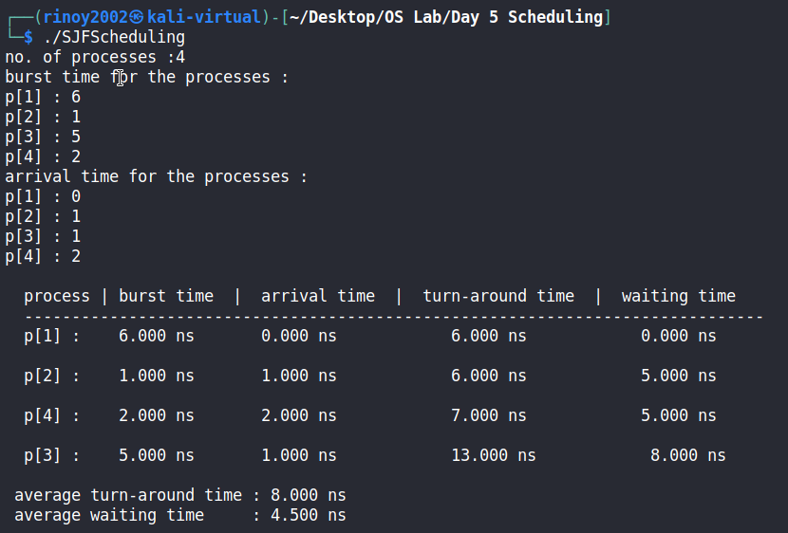
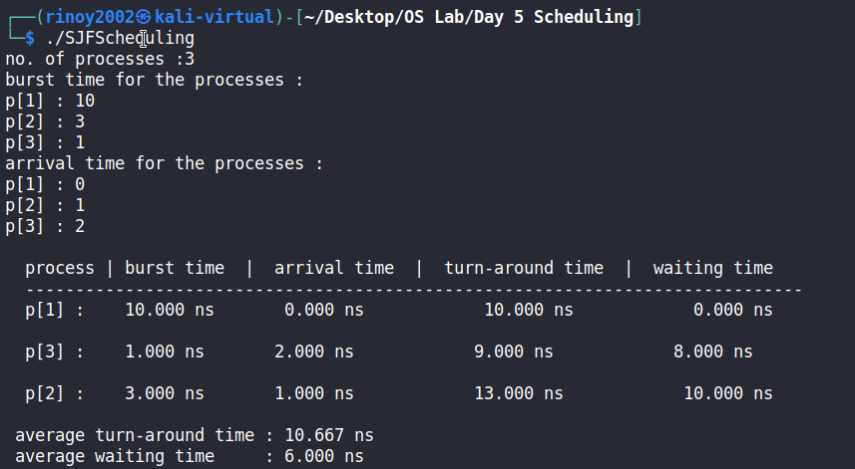

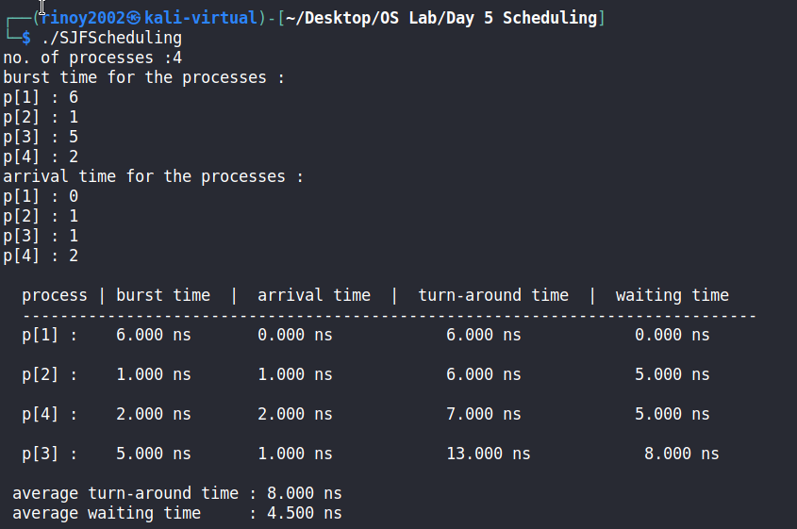
Program Code:

#include<stdio.h>
void main()
{
struct process{
int no;
float bt;
float at;
float tat;
float wt;
};
int n,i,j,quantum,count,var;
float time=0,temp1,temp2,temp3,temp4,avgtat,avgwt,stat=0,swt=0,sum;
printf(" no. of processes :");
scanf("%d",&n);
struct process p[n];
float temp[n];
printf(" burst time for the processes :\n");
for(i=0;i<n;i++){
printf(" p[%d] : ",i+1);
scanf("%f",&p[i].bt);
temp[i]=p[i].bt;
}
printf(" arrival time for the processes :\n");
for(i=0;i<n;i++){
printf(" p[%d] : ",i+1);
scanf("%f",&p[i].at);
}
for(i=0;i<n;i++){
p[i].no = i+1;
}
printf(" time quantum for the processes: ");
scanf("%d", &quantum);
for(i=0;i<n;i++){
for(j=0;j<n-i-1;j++){
if(p[j].at>p[j+1].at){
temp1 = p[j].no;
temp2 = p[j].bt;
temp3 = p[j].at;
temp4 = temp[j];
p[j].no = p[j+1].no;
p[j].bt = p[j+1].bt;
p[j].at = p[j+1].at;
temp[j] = temp[j+1];
p[j+1].no = temp1;
p[j+1].bt = temp2;
p[j+1].at = temp3;
temp[j+1] = temp4;
}
}
}
sum=p[0].at;
var=n;
for( i = 0; var!=0; ){
if(temp[i] <= quantum && temp[i] > 0){
sum = sum + temp[i];
temp[i] = 0;
count=1;
}
else if(temp[i] > 0){
temp[i] = temp[i] - quantum;
sum = sum + quantum;
}
if(temp[i]==0 && count==1){
var--;
p[i].tat=sum-p[i].at;
p[i].wt=sum-p[i].at-p[i].bt;
swt = swt+p[i].wt;
stat = stat+p[i].tat;
count =0;
}
if(i==n-1){
i=0;
}
else if(p[i+1].at<=sum){
i++;
}
/*else if(p[i+1].at>=sum){
sum=p[i+1].at;
i++;
}*/
else{
i=0;
}
}
avgtat = stat/n;
avgwt = swt/n;
printf("\n process | burst time | arrival time | turn-around time | waiting time \n");
printf(" ------------------------------------------------------------------------------\n");
for(i=0;i<n;i++){
printf(" p[%d] : ",p[i].no);
printf(" %.3f ms",p[i].bt);
printf(" %.3f ms",p[i].at);
printf(" %.3f ms",p[i].tat);
printf(" %.3f ms\n\n",p[i].wt);
}
printf(" average turn-around time : %.3f ms\n",avgtat);
printf(" average waiting time : %.3f ms\n",avgwt);
}

Sample Output:

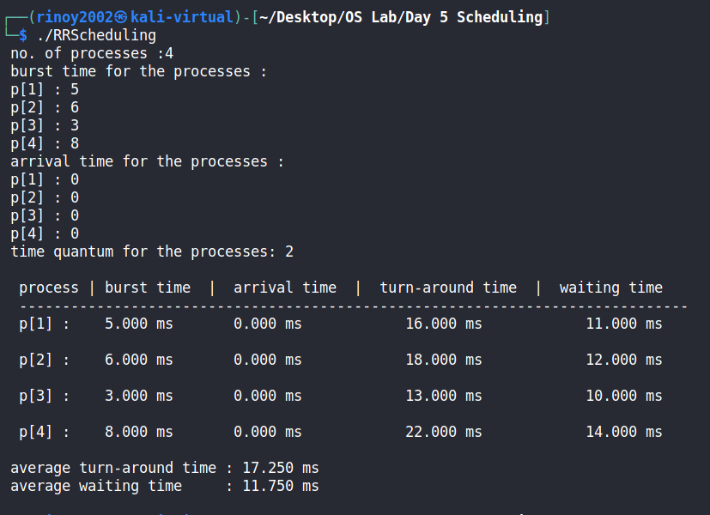

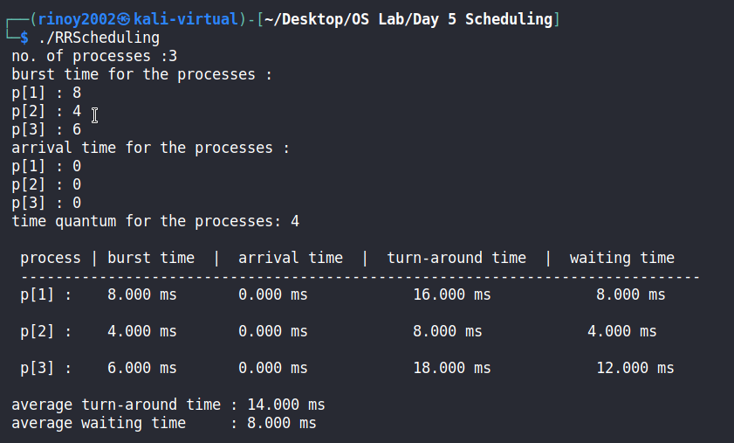

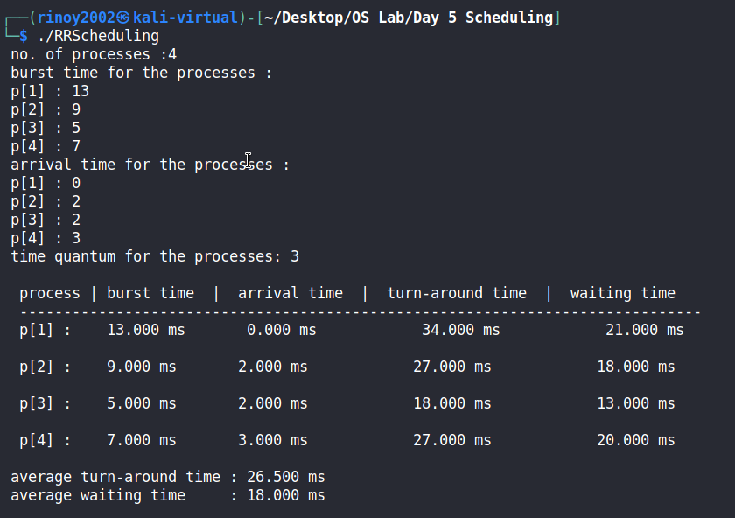

Program Code:

#include<stdio.h>
void main()
{
struct process{
int no;
float bt;
float at;
float tat;
float wt;
int pr;
};
int n,i,j,d,k=1,min,temp4;
float time=0,temp1,temp2,temp3,avgtat,avgwt,stat=0,swt=0,sum,btime;
printf("no. of processes :");
scanf("%d",&n);
struct process p[n];
printf("burst time for the processes :\n");
for(i=0;i<n;i++){
printf("p[%d] : ",i+1);
scanf("%f",&p[i].bt);
}
printf("arrival time for the processes :\n");
for(i=0;i<n;i++){
printf("p[%d] : ",i+1);
scanf("%f",&p[i].at);
}
printf("priority for the processes :\n");
for(i=0;i<n;i++){
printf("p[%d] : ",i+1);
scanf("%d",&p[i].pr);
}
for(i=0;i<n;i++){
p[i].no = i+1;
}
for(i=0;i<n;i++){
for(j=0;j<n-i-1;j++){
if(p[j].pr>p[j+1].pr){
temp1 = p[j].no;
temp2 = p[j].bt;
temp3 = p[j].at;
temp4 = p[j].pr;
p[j].no = p[j+1].no;
p[j].bt = p[j+1].bt;
p[j].at = p[j+1].at;
p[j].pr = p[j+1].pr;
p[j+1].no = temp1;
p[j+1].bt = temp2;
p[j+1].at = temp3;
p[j+1].pr = temp4;
}
}
}
for(i=0;i<n;i++){
for(j=0;j<n-i-1;j++){
if(p[j].at>p[j+1].at){
temp1 = p[j].no;
temp2 = p[j].bt;
temp3 = p[j].at;
temp4 = p[j].pr;
p[j].no = p[j+1].no;
p[j].bt = p[j+1].bt;
p[j].at = p[j+1].at;
p[j].pr = p[j+1].pr;
p[j+1].no = temp1;
p[j+1].bt = temp2;
p[j+1].at = temp3;
p[j+1].pr = temp4;
}
}
}
for(j=0;j<n;j++){
btime=btime+p[j].bt;
min=p[k].pr;
for(i=k;i<n;i++){
if ((btime>=p[i].at) && (p[i].pr<min)){
min = p[i].pr;
temp1 = p[i].no;
temp2 = p[i].bt;
temp3 = p[i].at;
temp4 = p[i].pr;
p[i].no = p[k].no;
p[i].bt = p[k].bt;
p[i].at = p[k].at;
p[i].pr = p[k].pr;
p[k].no = temp1;
p[k].bt = temp2;
p[k].at = temp3;
p[k].pr = temp4;
}
}
k++;
}
sum = p[0].at;
for(i=0;i<n;i++){
if(sum<p[i].at){
sum=p[i].at;
}
sum = sum + p[i].bt;
p[i].tat=sum-p[i].at;
p[i].wt=p[i].tat-p[i].bt;
stat=stat+p[i].tat;
swt=swt+p[i].wt;
}
avgtat = stat/n;
avgwt = swt/n;
printf("\n process | burst time | arrival time | priority | turn-around time | waiting time \n");
printf(" -------------------------------------------------------------------------------------------\n");
for(i=0;i<n;i++){
printf(" p[%d] : ",p[i].no);
printf(" %.3f ns",p[i].bt);
printf(" %.3f ns",p[i].at);
printf(" %d",p[i].pr);
printf(" %.3f ns",p[i].tat);
printf(" %.3f ns\n\n",p[i].wt);
}
printf(" average turn-around time : %.3f ns\n",avgtat);
printf(" average waiting time : %.3f ns\n",avgwt);
}

Sample Output:

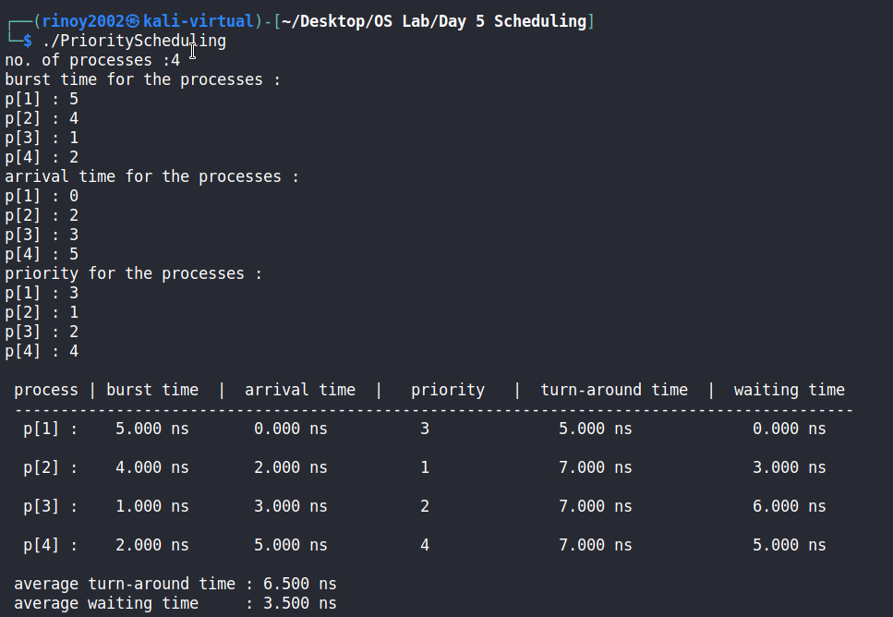

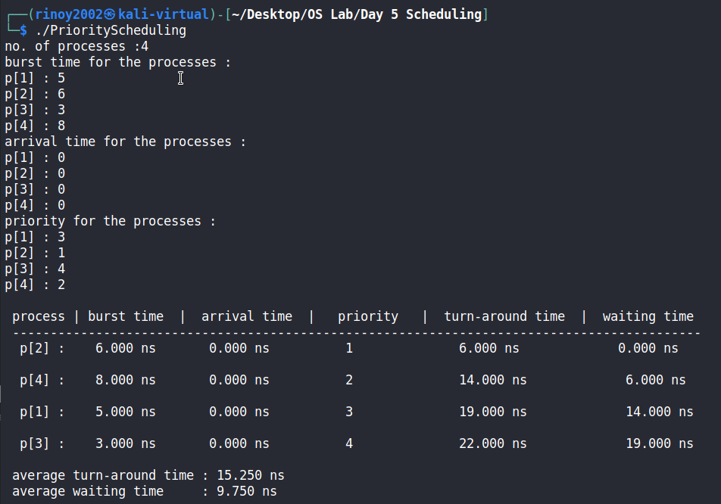

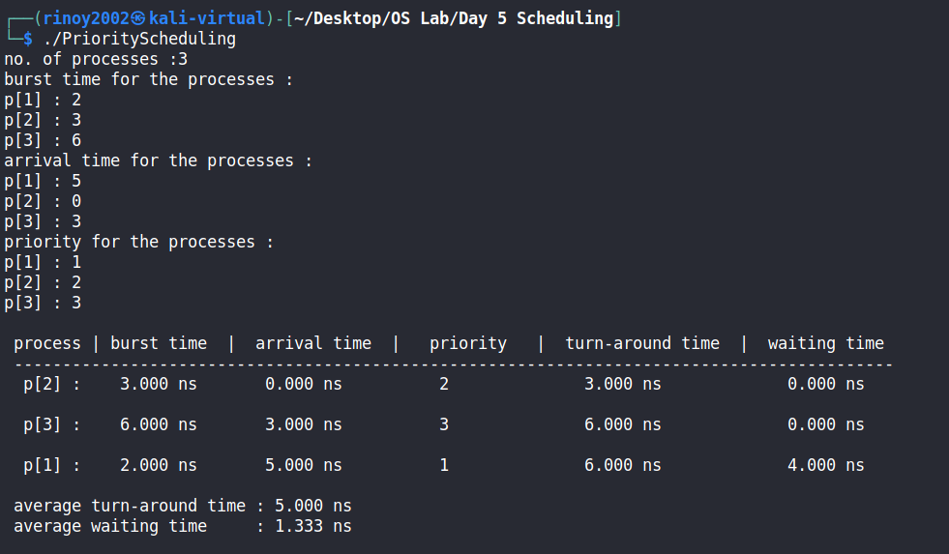

Program Code:

#include <stdio.h>
void main(){
int n,m,i,j,k;
printf("\n Enter total number of processes : ");
scanf("%d", &n);
printf("\n Enter total number of resources : ");
scanf("%d", &m);
int Alloc[n][m],Max[n][m],Need[n][m],Avail[m],Finish[n],Work[m],count=0,flag,seq[n],l=0;
for(i = 0; i < n; i++){
printf("\n Process %d\n", i);
for(j = 0; j < m; j++){
printf(" Allocation for resource %d : ", j+1 );
scanf("%d", &Alloc[i][j]);
printf(" Maximum for resource %d : ", j+1 );
scanf("%d", &Max[i][j]);
}
}
printf("\n Available Resources : \n");
for (j = 0; j < m; j++){
printf(" Resource %d : ", j+1);
scanf("%d", &Avail[j]);
}
for(i = 0; i < n; i++){
for (j = 0; j < m; j++){
Need[i][j] = Max[i][j] - Alloc[i][j];
}
}
printf("\n Allocation Matrix : \n");
for(i = 0; i < n; i++){
for (j = 0; j < m; j++){
printf(" %d ",Alloc[i][j]);
}
printf("\n");
}
printf("\n Maximum Matrix : \n");
for(i = 0; i < n; i++){
for (j = 0; j < m; j++){
printf(" %d ",Max[i][j]);
}
printf("\n");
}
printf("\n Available Matrix : \n");
for (j = 0; j < m; j++){
printf(" %d ",Avail[j]);
}
printf("\n\n Need Matrix : \n");
for(i = 0; i < n; i++){
for (j = 0; j < m; j++){
printf(" %d ",Need[i][j]);
}
printf("\n");
}
for(i=0;i<n;i++){
Finish[i]=0;
}
for(j=0;j<m;j++){
Work[j]=Avail[j];
}
for (k = 0; k < n; k++){
for (i = 0; i < n; i++){
if (Finish[i] == 0){
flag = 0;
for (j = 0; j < m; j++){
if (Need[i][j] > Work[j]){
flag = 1;
}
}
if (flag== 0 && Finish[i] == 0){
for (j = 0; j < m; j++){
Work[j] += Alloc[i][j];
}
Finish[i] = 1;
count++;
seq[l]=i;
l++;
}
}
}
}
if(count==n){
printf(" Safe Sequence : ");
for(i=0;i<l;i++){
printf(" P%d ",seq[i]);
}
}else{
printf(" Deadlock Occurs ");
}
}

Sample Output:
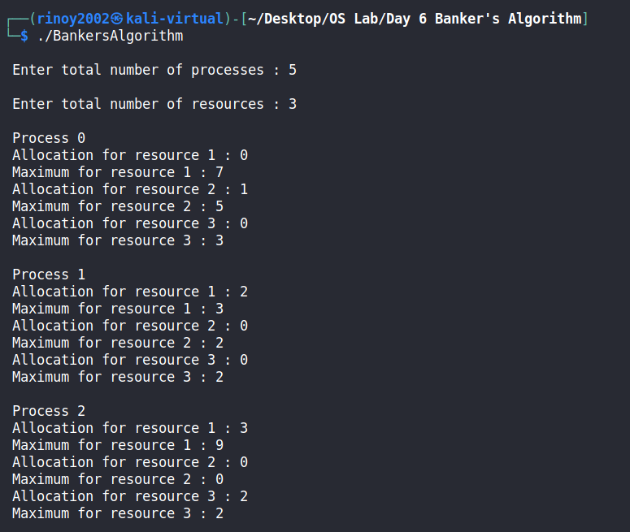

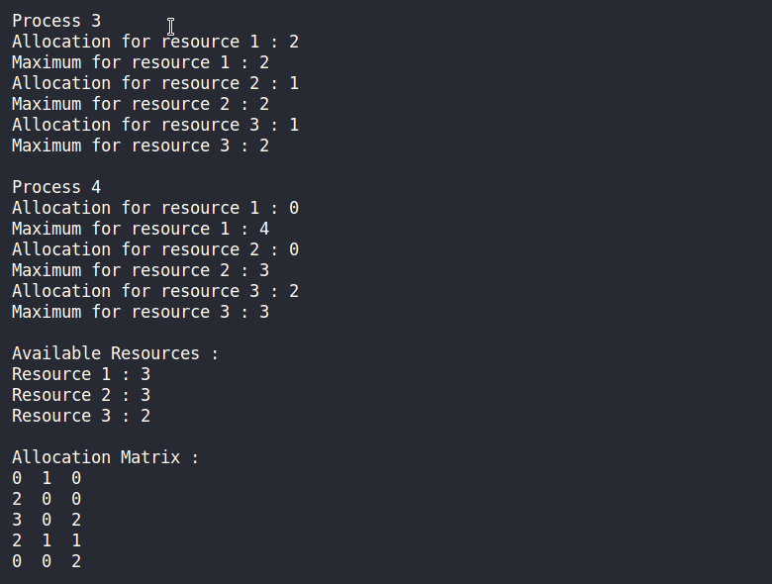

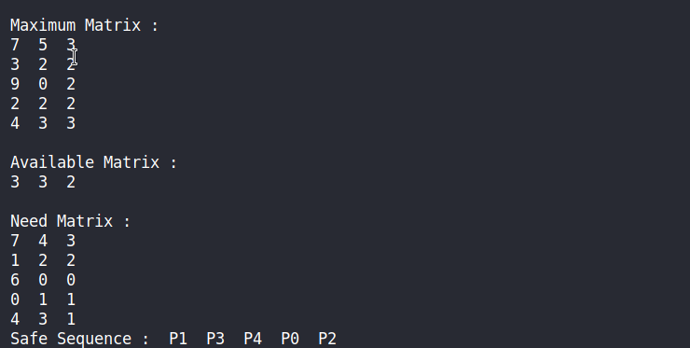

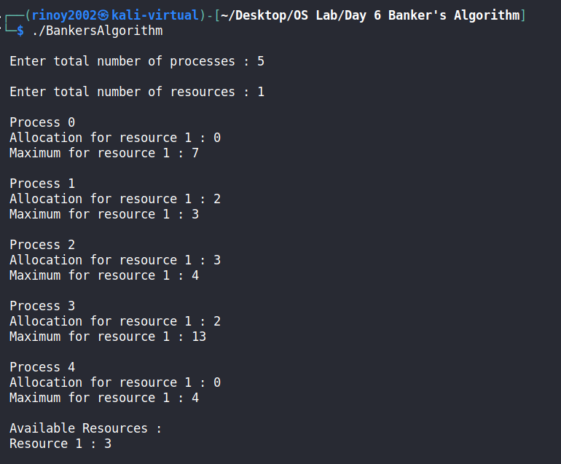

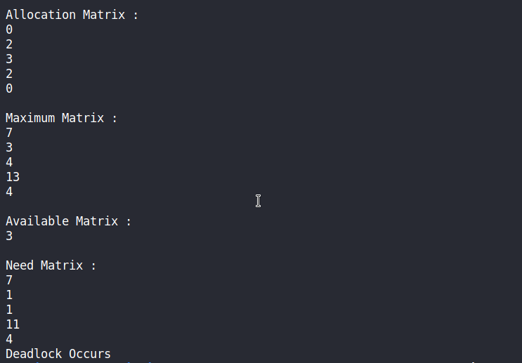

Program Code :

#include<stdio.h>
void main(){
int block[50], process[50], bsize, psize, iscompleted[50], allocation[50], i, j;
printf(" Enter no. of memory blocks: ");
scanf("%d", &bsize);
printf("\n Enter size of each memory block: ");
for(i = 0; i < bsize; i++){
scanf("%d", &block[i]);
}
printf("\n Enter no. of processes: ");
scanf("%d", &psize);
printf("\n Enter size of each process: ");
for(i = 0; i < psize; i++){
scanf("%d", &process[i]);
}
for(i = 0; i < bsize; i++){
allocation[i] = -1;
}
for(i = 0; i < psize; i++){
iscompleted[i] = 0;
}
for(i = 0; i < psize; i++){
for(j = 0; j < bsize; j++){
if(allocation[j] == -1 && block[j] >= process[i]){
allocation[j] = i;
iscompleted[i] = 1;
break;
}
}
}
printf("\n Block no.\tsize\t\tprocess no.\t\tsize\t\tunused memory\n");
for(i = 0; i < bsize; i++){
printf("\n %d\t\t%dK\t\t", i+1, block[i]);
if(allocation[i] != -1){
printf("%d\t\t\t%dK\t\t%dK",allocation[i]+1,process[allocation[i]],block[i]-process[allocation[i]]);
}else{
printf("Not allocated\t\t\t\t%dK",block[i]);
}
}
for(i = 0; i < psize; i++){
if(iscompleted[i] != 1){
printf("\n process %d can't be allocated",i+1);
}
}
}

Sample Output :

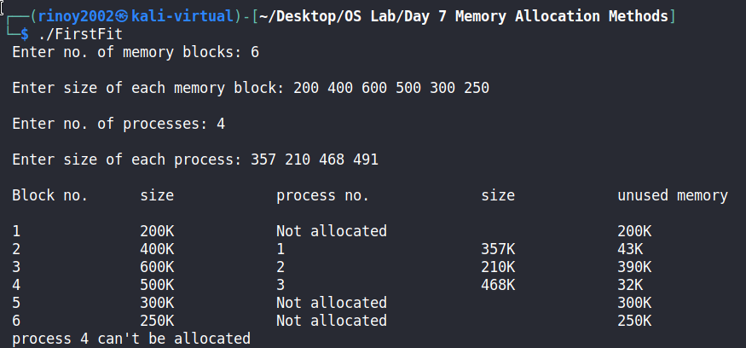

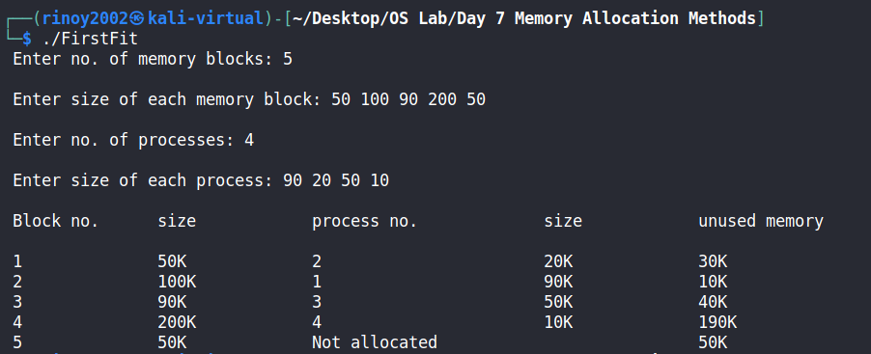

Program Code :

#include<stdio.h>
void main(){
int block[50], process[50], bsize, psize, iscompleted[50], allocation[50],i, j,index;
printf(" Enter no. of memory blocks: ");
scanf("%d", &bsize);
printf("\n Enter size of each memory block: ");
for(i = 0; i < bsize; i++){
scanf("%d", &block[i]);
}
printf("\n Enter no. of processes: ");
scanf("%d", &psize);
printf("\n Enter size of each process: ");
for(i = 0; i < psize; i++){
scanf("%d", &process[i]);
}
for(i = 0; i < bsize; i++){
allocation[i] = -1;
}
for(i = 0; i < psize; i++){
iscompleted[i] = 0;
}
for(i=0;i<psize;i++){
index =-1;
for(j=0;j<bsize;j++){
if((block[j]>=process[i])&&(allocation[j]==-1)){
if(index==-1){
index=j;
}else if( block[index] < block[j]){
index = j;
}
}
}
if(index!=-1){
allocation[index] = i;
iscompleted[i]=1;
}
}
printf("\n Block no.\tsize\t\tprocess no.\t\tsize\t\tunused memory\n");
for(i = 0; i < bsize; i++){
printf("\n %d\t\t%dK\t\t", i+1, block[i]);
if(allocation[i] != -1){
printf("%d\t\t\t%dK\t\t%dK",allocation[i]+1,process[allocation[i]],block[i]-process[allocation[i]]);
}else{
printf("Not allocated\t\t\t\t%dK",block[i]);
}
}
for(i = 0; i < psize; i++){
if(iscompleted[i] != 1){
printf("\n process %d can't be allocated",i+1);
}
}
}

Sample Output :

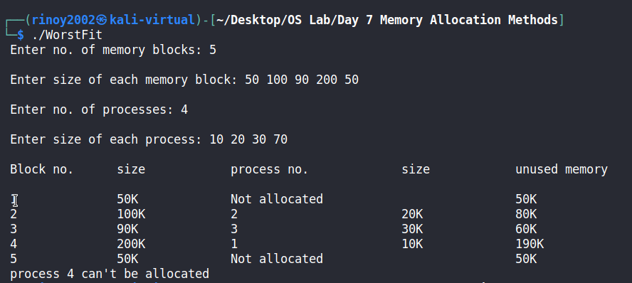

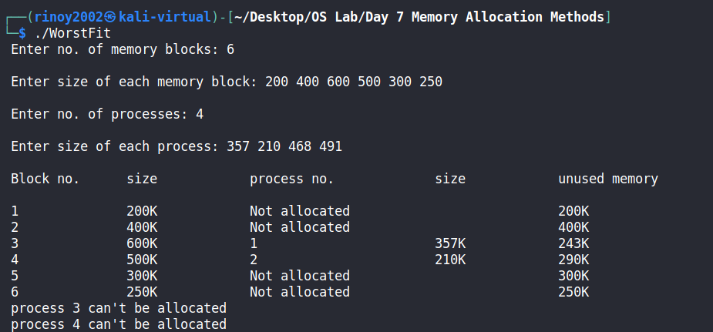

Program Code :

#include<stdio.h>
void main(){
int block[50], process[50], bsize, psize, iscompleted[50], allocation[50],temp,i, j,index=-1;
printf(" Enter no. of memory blocks: ");
scanf("%d", &bsize);
printf("\n Enter size of each memory block: ");
for(i = 0; i < bsize; i++){
scanf("%d", &block[i]);
}
printf("\n Enter no. of processes: ");
scanf("%d", &psize);
printf("\n Enter size of each process: ");
for(i = 0; i < psize; i++){
scanf("%d", &process[i]);
}
for(i = 0; i < bsize; i++){
allocation[i] = -1;
}
for(i = 0; i < psize; i++){
iscompleted[i] = 0;
}
for(i=0;i<psize;i++){
index =-1;
for(j=0;j<bsize;j++){
if((block[j]>=process[i])&&(allocation[j]==-1)){
if(index==-1){
index=j;
}else if( block[index] > block[j]){
index = j;
}
}
}
if(index!=-1){
allocation[index] = i;
iscompleted[i]=1;
}
}
printf("\n Block no.\tsize\t\tprocess no.\t\tsize\t\tunused memory\n");
for(i = 0; i < bsize; i++){
printf("\n %d\t\t%dK\t\t", i+1, block[i]);
if(allocation[i] != -1){
printf("%d\t\t\t%dK\t\t%dK",allocation[i]+1,process[allocation[i]],block[i]-process[allocation[i]]);
}else{
printf("Not allocated\t\t\t\t%dK",block[i]);
}
}
for(i = 0; i < psize; i++){
if(iscompleted[i] != 1){
printf("\n process %d can't be allocated",i+1);
}
}
}

Sample Output :

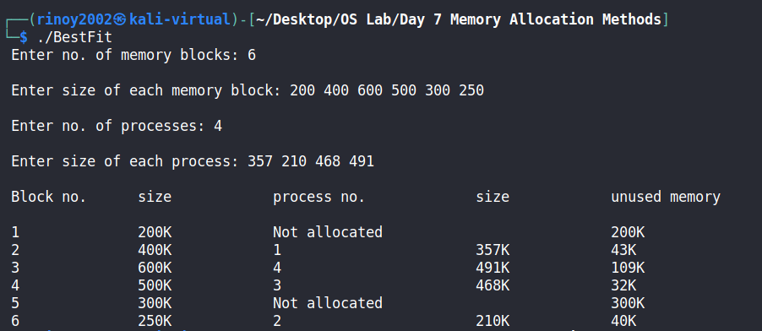

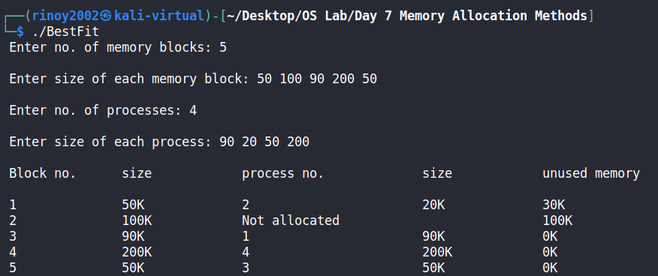

Program Code :

#include<stdio.h>
#include<unistd.h>
#include<sys/wait.h>
void fibonacci(int n){
int a =0 ,b = 1,c,i;
printf(" %d %d ",a,b);
c=a+b;
while(a+b<=n) {
c = a + b;
printf(" %d ",c);
a = b;
b = c;
}
}
void prime(int n){
int i,j,flag;
for (i=2; i<=n; i++){
flag=1;
for (j=2; j<=i/2; j++){
if(i%j == 0){
flag=0;
break;
}
}
if(flag==1){
printf(" %d ",i);
}
}
}
int main(){
int n;
printf("\n\nEnter the value of n :");
scanf("%d",&n);
if(fork() ==0 ){
printf("\n\nChild Process : Fibonacci Series \n");
fibonacci(n);
}else{
wait(NULL);
printf("\n\nParent Process : Prime Numbers \n");
prime(n);
}
printf("\n");
}

Sample Output:

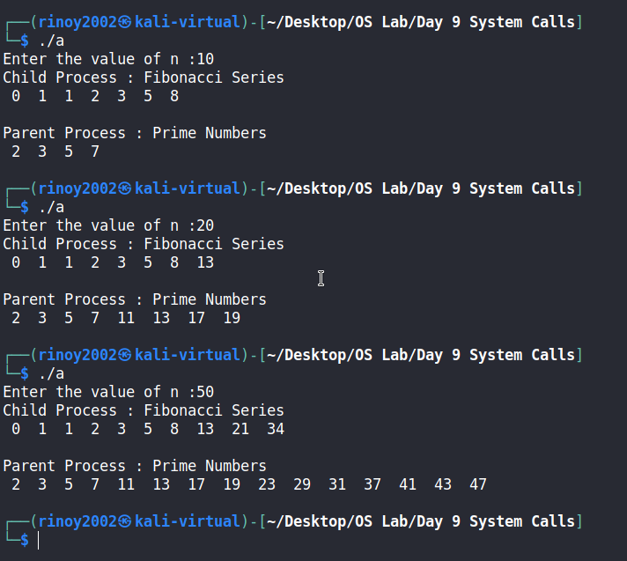

Program Code :

#include<stdio.h>
#include<unistd.h>
#include<sys/wait.h>
void main(){
int n,i;
printf("Enter the value of N : ");
scanf("%d",&n);
for(i =0; i<n ; i++){
if(fork() == 0){
printf("Level %d: Child pid: %d Parent pid: %d \n",i,getpid(),getppid());
}else{
wait(NULL);
break;
}
}
}

Sample Output :

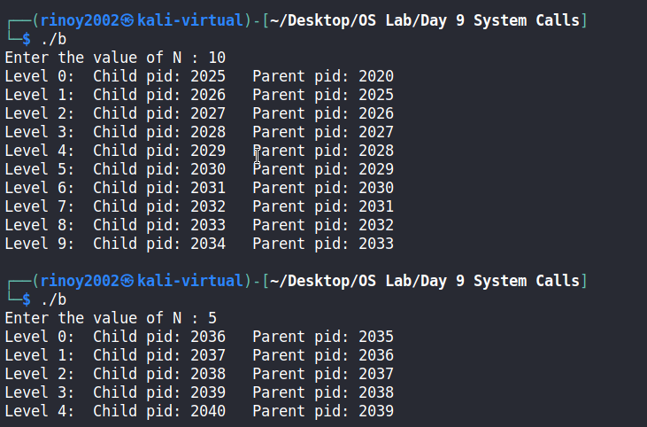

Program Code :

#include <stdio.h>
#include <unistd.h>
#include <sys/wait.h>
void main() {
printf("Parent A: %d\n", getpid());
if (fork() == 0) {
printf(" Child B: %d forked by Parent A: %d\n", getpid(), getppid());
if (fork() == 0) {
printf(" Child D: %d forked by Parent B: %d\n", getpid(), getppid());
if (fork() == 0) {
printf(" Child H: %d forked by Parent D: %d\n", getpid(), getppid());
if (fork() == 0) {
printf(" Child I: %d forked by Parent H: %d\n", getpid(), getppid());
}else{
wait(NULL);
}
}else{
wait(NULL);
}
}else if (fork() == 0) {
printf(" Child E: %d forked by Parent B: %d\n", getpid(), getppid());
}else if (fork() == 0) {
printf(" Child F: %d forked by Parent B: %d\n", getpid(), getppid());
}else{
wait(NULL);
}
}else if (fork() == 0) {
printf(" Child C: %d forked by Parent A: %d\n", getpid(), getppid());
if (fork() == 0) {
printf(" Child G: %d forked by Parent C: %d\n", getpid(), getppid());
}else{
wait(NULL);
}
}else{
wait(NULL);
}
}
Sample Output:

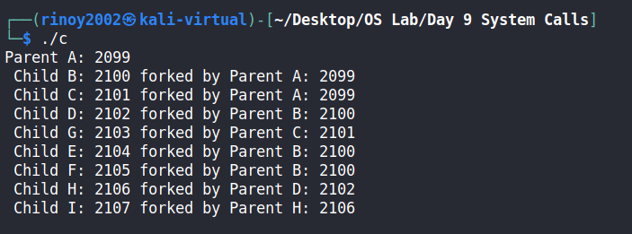

Program Code :

#include<stdio.h>
int isHit(int data,int frame[],int fsize){
int hit=0;
for(int j=0; j<fsize; j++){
if(frame[j]==data){
hit=1;
break;
}
}
return hit;
}
void main(){
int pgsize,fsize,pstring[50],i,nfault=0,k;
printf("\nEnter length of page reference string:");
scanf("%d",&pgsize);
printf("\nEnter the page reference string:");
for(i=0; i<pgsize; i++){
scanf("%d",&pstring[i]);
}
printf("\nEnter no of frames:");
scanf("%d",&fsize);
int frame[fsize];
for(i=0; i<fsize; i++){
frame[i]=9999;
}
for(i=0; i<pgsize; i++){
printf("\nFor %d :",pstring[i]);
if(isHit(pstring[i],frame,fsize)==0){
for(k=0; k<fsize-1; k++){
frame[k]=frame[k+1];
}
frame[k]=pstring[i];
nfault++;
for (k=0; k<fsize; k++){
if(frame[k]!=9999){
printf(" %d",frame[k]);
}
}
}
else{
printf("No page fault");
}
}
printf("\nTotal no of page faults: %d",nfault);
}

Sample Output:

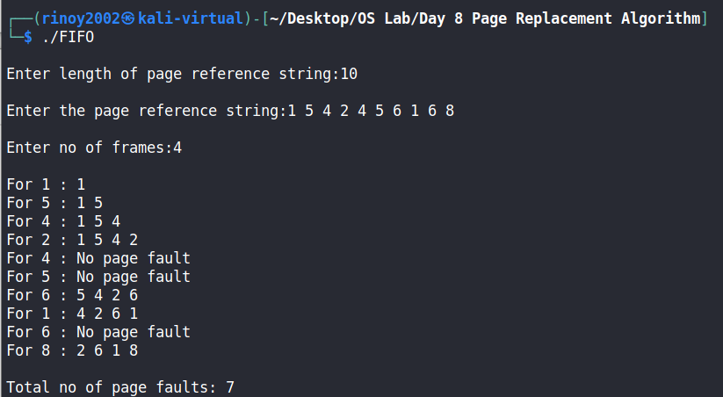
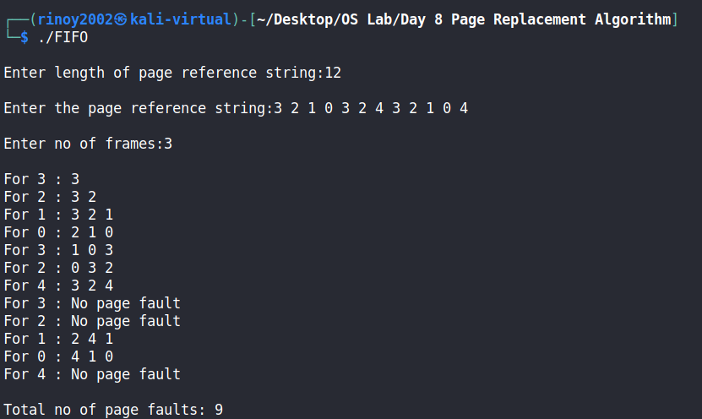

Program Code :

#include<stdio.h>
int isHit(int data,int frame[],int fsize){
int hit=0;
for(int j=0; j<fsize; j++){
if(frame[j]==data){
hit=1;
break;
}
}
return hit;
}
void main(){
int pgsize,fsize,pstring[50],i,j,nfault=0,k,past_index[50],page,found,min,index;
printf("\nEnter length of page reference string:");
scanf("%d",&pgsize);
printf("\nEnter the page reference string:");
for(i=0; i<pgsize; i++){
scanf("%d",&pstring[i]);
}
printf("\nEnter no of frames:");
scanf("%d",&fsize);
int frame[fsize];
for(i=0; i<fsize; i++){
frame[i]=9999;
}
for(i=0; i<pgsize; i++){
printf("\nFor %d :",pstring[i]);
if(isHit(pstring[i],frame,fsize)==0){
for(j=0; j<fsize;j++){
page = frame[j];
found=0;
for(k=i-1;k>=0;k--){
if(page==pstring[k]){
past_index[j]=k;
found=1;
break;
}
else{
found=0;
}
}
if(found==0){
past_index[j]=-9999;
}
}
min=9999;
/*printf("\n");
for(int l=0;l<fsize;l++){
printf(" %d ",past_index[l]);
}
printf("\n");*/
for(j=0; j<fsize; j++)
{
if(past_index[j]<min)
{
min=past_index[j];
index=j;
}
}
frame[index]=pstring[i];
nfault++;
for (k=0; k<fsize; k++){
if(frame[k]!=9999){
printf(" %d",frame[k]);
}
}
}
else{
printf("No page fault");
}
}
printf("\nTotal no of page faults: %d",nfault);
}

Sample Output:

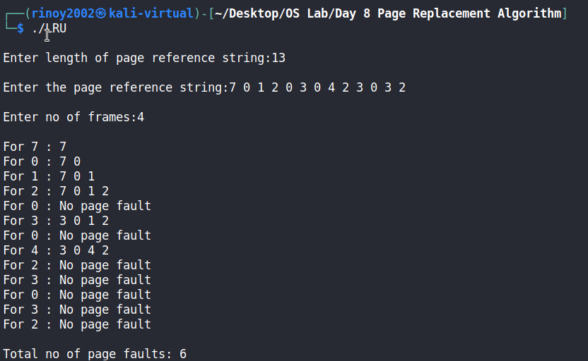

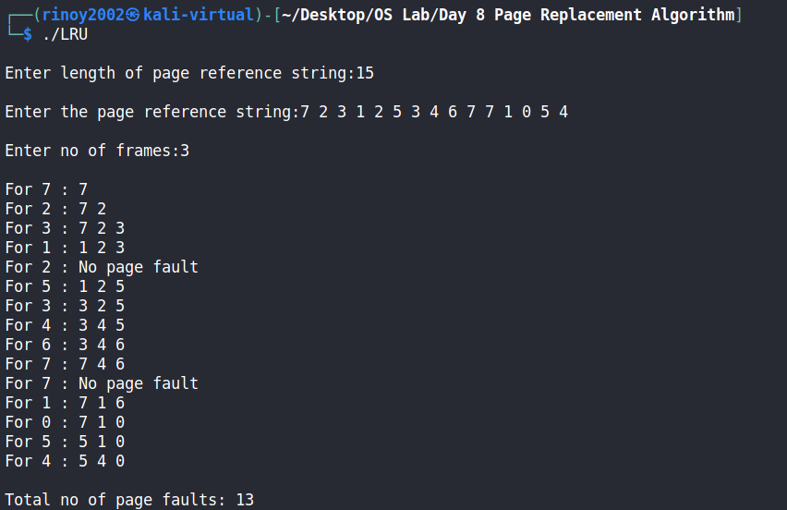

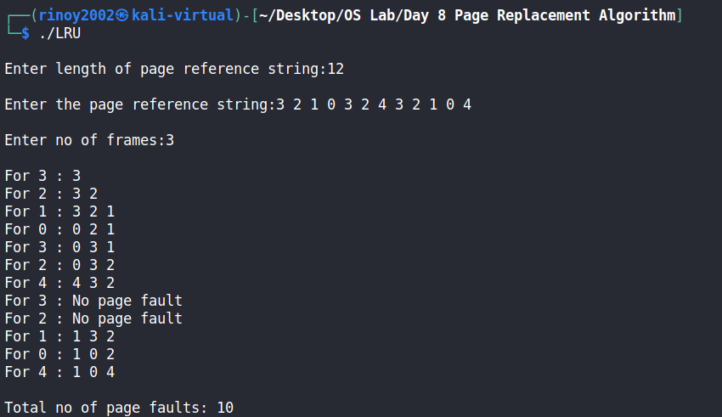

Program Code :

#include<stdio.h>
int isHit(int data,int frame[],int fsize){
int hit=0;
for(int j=0; j<fsize; j++){
if(frame[j]==data){
hit=1;
break;
}
}
return hit;
}
void main(){
int pgsize,fsize,pstring[50],i,j,nfault=0,k,count[50],min,index,val;
printf("\nEnter length of page reference string:");
scanf("%d",&pgsize);
printf("\nEnter the page reference string:");
for(i=0; i<pgsize; i++){
scanf("%d",&pstring[i]);
}
printf("\nEnter no of frames:");
scanf("%d",&fsize);
int frame[fsize];
for(i=0; i<fsize; i++){
frame[i]=9999;
count[i]=0;
}
j=0;
for(i=0; i<pgsize; i++){
printf("\nFor %d :",pstring[i]);
if(isHit(pstring[i],frame,fsize)==0){
if(j<fsize){
frame[j]=pstring[i];
count[j]=count[j]+1;
j++;
}else{
min=9999;
for(k=0; k<fsize; k++){
if(count[k]<min){
min=count[k];
index=k;
}
}
for(k=index;k<fsize-1;k++){
frame[k]=frame[k+1];
count[k]=count[k+1];
}
frame[fsize-1]=pstring[i];
val=0;
for(k=0; k<=i; k++){
if(pstring[i]==pstring[k]){
val=val+1;
}
}
count[fsize-1]=val;
}
for (k=0; k<fsize; k++){
if(frame[k]!=9999){
printf(" %d",frame[k]);
}
}
nfault++;
}
else{
for(k=0; k<fsize; k++){
if(frame[k]==pstring[i]){
index=k;
break;
}
}
count[k]=count[k]+1;
printf("No page fault");
}
printf("\n");
for(int l=0;l<fsize;l++){
printf(" %d ",count[l]);
}
}
printf("\nTotal no of page faults: %d",nfault);
}

Sample Output:

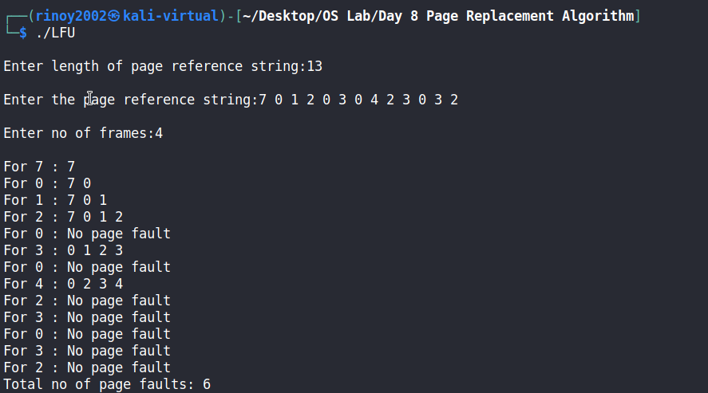

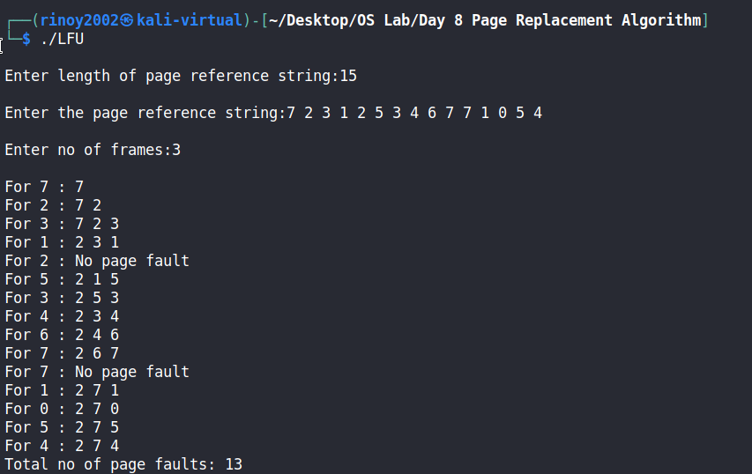

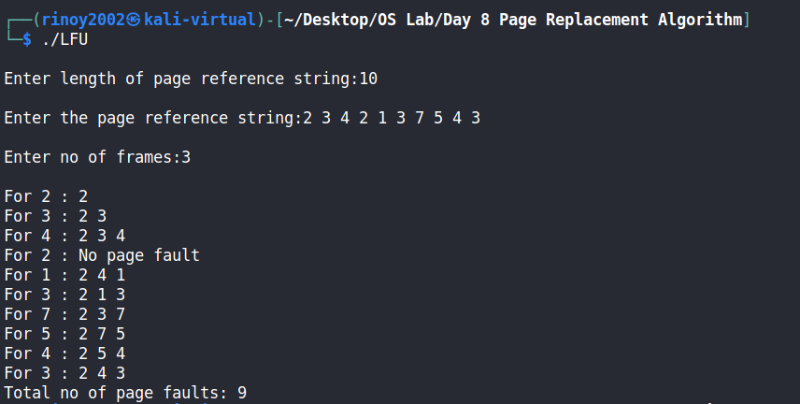

Program Code :

#include<stdio.h>
int mutex=1,full,empty,buffer[20];
int wait(int val){
return (--val);
}
int signal(int val){
return (++val);
}
void producer(int item){
empty=wait(empty);
mutex=wait(mutex);
buffer[full]=item;
printf(" Producer produces the item %d",item);
mutex=signal(mutex);
full=signal(full);
}
void consumer(){
full=wait(full);
mutex=wait(mutex);
int item = buffer[full];
printf(" Consumer consumes item %d",item);
mutex=signal(mutex);
empty=signal(empty);
}
void main(){
int n,size,var=1,item;
printf("Enter the size of Buffer :");
scanf("%d",&size);
full=0;
empty=size;
printf("\nProducer Consumer Problem");
printf("\n 1.Produce");
printf("\n 2.Consume");
printf("\n 3.Exit");
while(var==1){
printf("\nEnter your choice:");
scanf("%d",&n);
switch(n){
case 1:
if((mutex==1)&&(empty!=0)){
printf(" Enter item to add in Buffer : ");
scanf("%d",&item);
producer(item);
}else{
printf(" Buffer is full!!");
}break;
case 2:
if((mutex==1)&&(full!=0)){
consumer();
}else{
printf(" Buffer is empty!!");
}break;
case 3:
var=0;
break;
}
}
}
Sample Output:

